The Windows 7 Interface

Desktop Icons

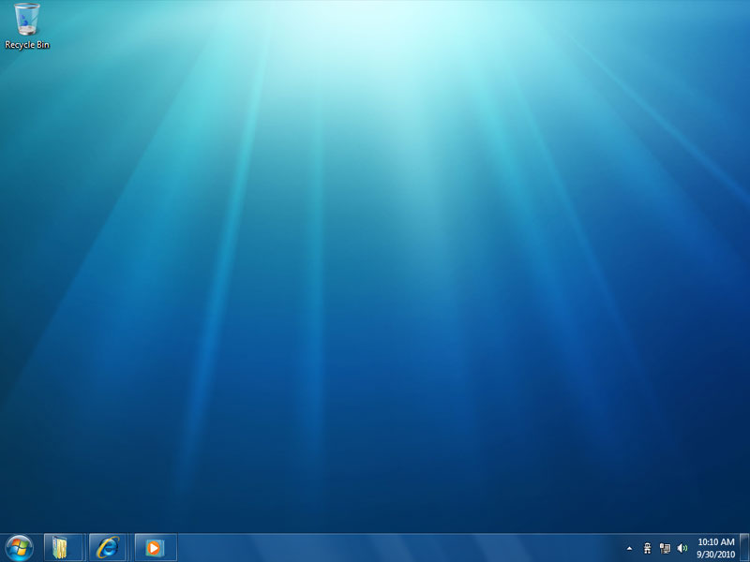

Start button Desktop Quick Launch toolbar Taskbar Notification Area

The screen above shows some of the elements of a typical Windows 7 desktop.

● The notification area (system tray) displays only the icons you choose. Windows hides the icons you seldom use (but that some programs insist on putting there), displaying only the ones that you’re actively using. The others are available with a single click.

Name any item that appears in the notification area: Internet Explorer

● The taskbar doesn’t squeeze in a button for every open window. Instead, when enough
windows are open to fill the taskbar, Windows combines buttons from the same application (such as multiple Microsoft Word documents) into a single button that you can expand with a quick click.
To do: try opening multiple Word documents and see them combined into a single button in the taskbar. Close all the windows when finished.

● Windows includes a toolbar called Quick Launch that docks on your taskbar and populates itself, default, with three icons: Internet Explorer, Windows Explorer, and Windows Media Player. With the toolbar in place, a single click of an icon initiates an action. You can easily drag new program icons onto the quick launch area.

Name any item that appears on the Quick Launch toolbar: Mozilla Firefox

Looking at the Content of the Start Menu
You can access your Programs, Control Panel, and much more from the Start Menu. You can change the look and feel of your Start Menu by right clicking on the taskbar and selecting Properties. Click on the Start Menu tab and select Customize to alter the interface to suit.

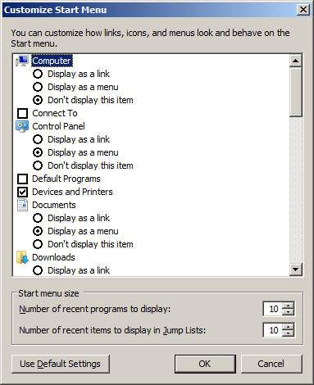

Windows Explorer
Used to access the file system. Can be opened from the quick launch or by right clicking on the Start button and selecting Open Windows Explorer.

You can turn on and off the Menu bar by selecting Organize -> Layout -> Menu bar

You can choose different View Options either from the View menu or by clicking the Views button on the Standard Buttons toolbar.

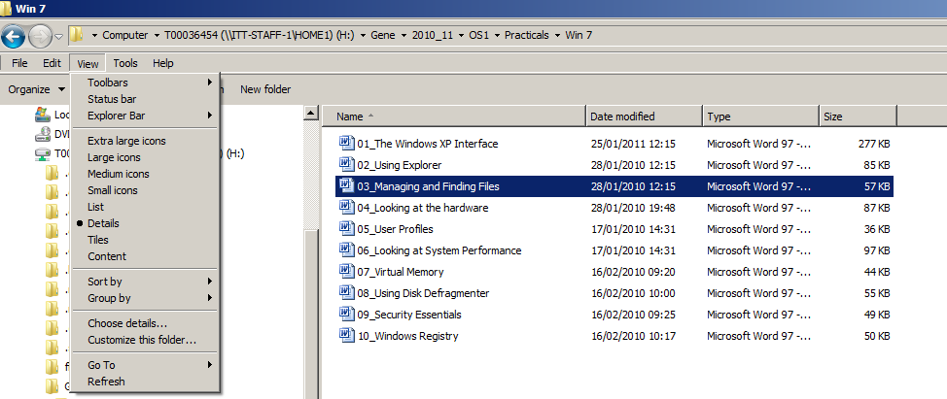

To do: try each of these options

Mapping Network Drives
You can map network drives by selecting Tools -> Map Network Drive

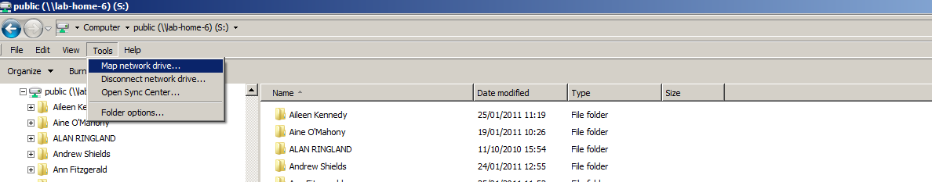

The following window opens and you can specify a path in the format \\server\share and associate this drive with a letter.

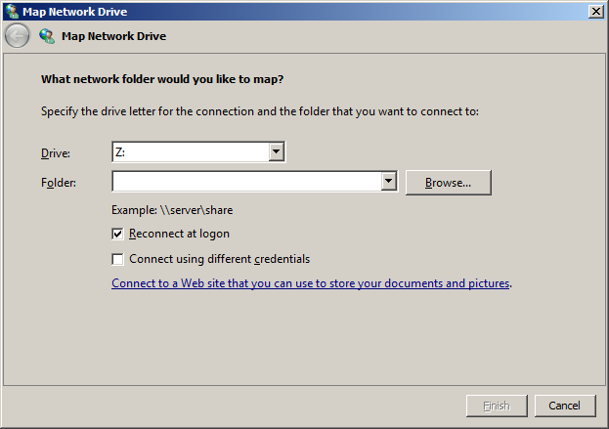

To do: What are the path to Xythos and the K: drive (labshare)? Xythos: \\XythosDrive\mydocs
K: \\labshare\lab_share

Searching for files/folders
You can search for files/folders by selecting an initial search location on the file system and specifying some search criteria in the search input box in the top right corner of Windows Explorer. E.g. The following searches the entire hard disk for JPEG images.

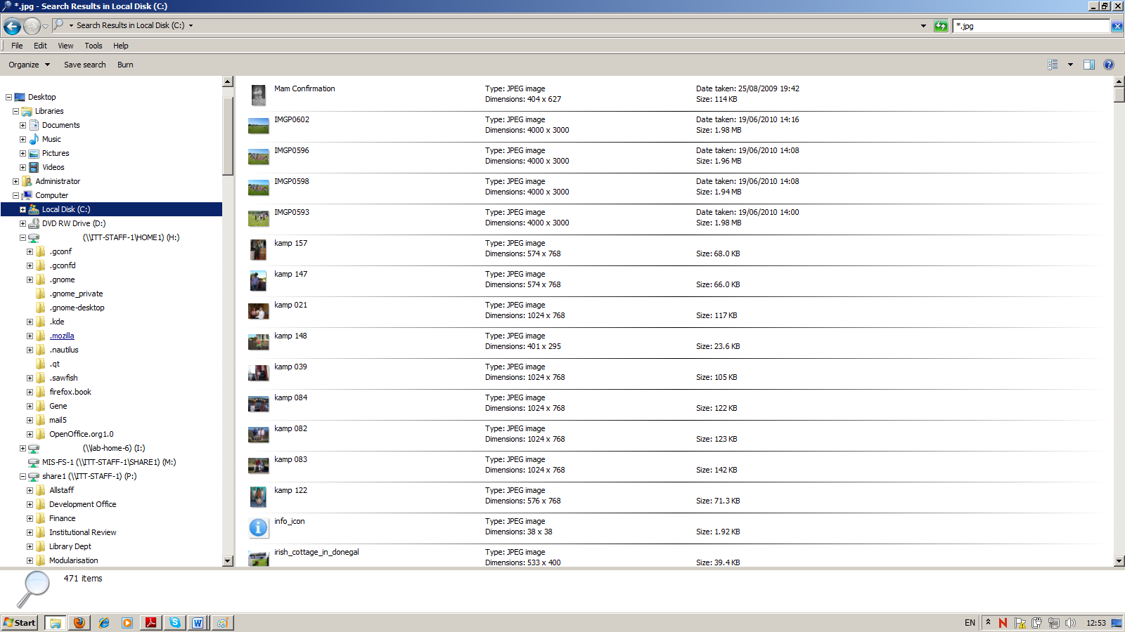
Using the Recycle Bin
The Recycle Bin provides protection against accidental erasure of files. In most cases, when you delete one or more files or folders, the deleted items go to the Recycle Bin, not into the ether. If you change your mind, you can go to the bin and recover the thrown-out items. Eventually, when the bin fills up, Windows begins emptying it, permanently deleting the files that have been there the longest.
The following kinds of deletions do not go to the Recycle Bin:
● Files stored on removable disks
● Files stored on network drives
● Files deleted from compressed (zipped) folders
You can bypass the Recycle Bin yourself, permanently deleting an item, by holding down the Shift key while you press the Delete key. You might want to do this if you need to get rid of some very large files and you’re sure you’ll never want these files back. Skipping the Recycle Bin in this case will reclaim some disk space.

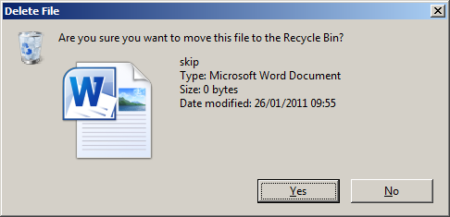
Figure: Deleting a file moves it to the Recycle Bin

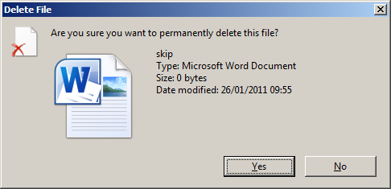
Figure: Skipping the Recycle Bin when deleting a file

Changing the Amount of Space Allocated to the Recycle Bin
Although the Recycle Bin folder (the place where you can see which files have been deleted and from which you can restore deleted files) lists deletions from all local hard drives together, Windows actually maintains separate recycling stores for each drive. By default, when a drive’s recycling store reaches 10% of the overall capacity of the drive, Windows begins deleting the oldest files from that store permanently.
1 Right-click the Recycle Bin icon on the desktop.
2 Choose Properties from the shortcut menu.
3 Specify a new Custom Maximum size.
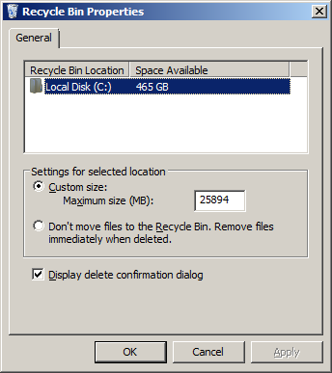

Restoring Files and Folders
When you open the Recycle Bin, Windows displays the names of recently deleted items in an ordinary Windows Explorer window. In Details view, you can see when each item was deleted and which folder it was deleted from. You can use the column headings to sort the folder—for example, to display the items that have been in the bin the longest at the top, with more recent arrivals below.
Note that deleted folders are shown only as folders; you don’t see the names of items contained within the folder. If you restore a deleted folder, however, Windows re-creates the folder and its contents.
The Restore command puts the item back in the folder from which it was deleted. If that
folder doesn’t currently exist, Windows asks your permission to re-create it.
If you want, you can restore a file or folder to a different location. You can drag an item out of the Recycle Bin and drop it wherever you want it.
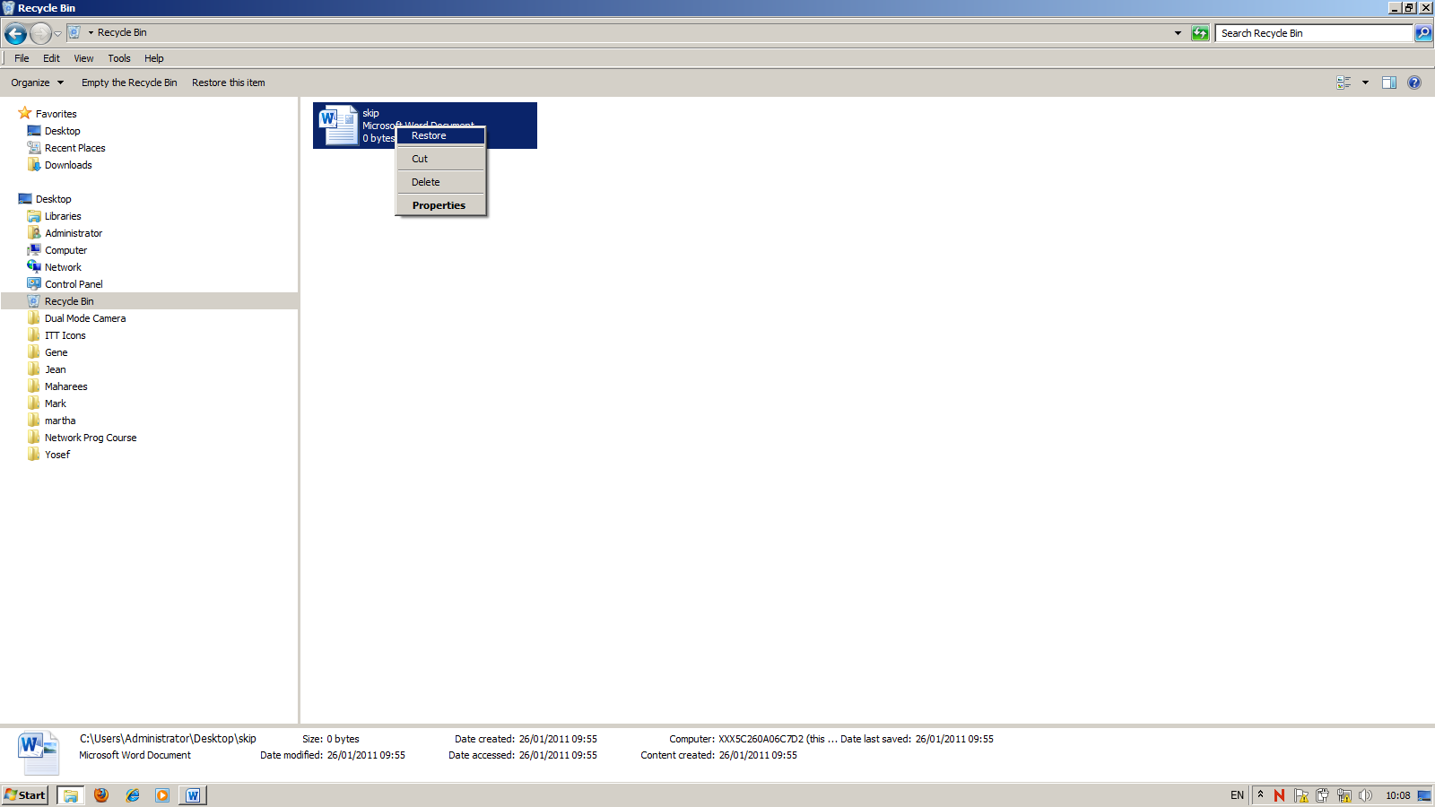

To do: Create a new folder on the desktop. Put any document in it. E.g. use notepad to create a file. Delete the folder and then restore it.

Purging the Recycle Bin
A deleted file sitting in your Recycle Bin takes up as much space as it did before it was deleted. If you’re deleting files to free up space for new programs and documents, transferring them to the Recycle Bin won’t help. You need to remove them permanently. The safest way to do this is to move the items to another storage medium—a different hard disk or a removable disk, for example.
If you’re sure you’ll never need a particular file again, however, you can delete it in the normal way and then purge it from the Recycle Bin. Display the Recycle Bin, select the item, and then press Delete. (Alternatively, you can simply press Shift+Delete to erase the file without sending it to the Recycle Bin.)
To empty the Recycle Bin entirely, right-click the Recycle Bin icon on your desktop and
choose Empty Recycle Bin from the shortcut menu. Or display the Recycle Bin and click
Empty The Recycle Bin in the task pane.

To do: delete permanently the folder on the desktop, you created above.

User Profiles
A user profile contains all the settings and files for a user’s work environment. This includes files that are specific to the user (such as cookies the user receives while browsing), documents in the My Documents folder and its subfolders, and shortcuts to network places.

Location and Content of User Profiles
By default, each user who logs on to a computer has a local user profile, which is created
when the user logs on for the first time. Local user profiles are stored in C:\Users. Each user profile is stored in a subfolder where the user t number is the folder name (for example, C:\Users\t000xxxx). Within a user’s profile folder, you’ll find a hierarchy of folders.

The profile includes the following folders:
- Contacts
- Desktop This folder contains all items stored on the user’s desktop, including files and shortcuts.
- Downloads
- Favorites This folder contains Internet Explorer favorites.
- Links
- My Documents This folder is the default target for the My Documents shortcut that appears on the Start menu, in the Windows Explorer task pane (under Other Places), and elsewhere. My Documents is the default location for storing user documents in most applications. When you view the profile folders for another user, the user’s name replaces My, although the actual folder name for all users is My Documents.
- My Music
- My Pictures
- My Videos

To do: Name any item that appears in the Desktop folder. Check that this is on your desktop: Computer

